**DAILY ONLINE ACTIVITIES SUMMARY**

|  |  |  |  |  |  |  |  |  |
| --- | --- | --- | --- | --- | --- | --- | --- | --- |
| **Date:** | **6-6-2020** | | | | | **Name:** | **poojashree** | |
| **Sem & Sec** | **8th sem A sec** | | | | | **USN:** | **4al16cs065** | |
| **Online Test Summary** | | | | | | | | |
| **Subject** | | **iot** | | | | | | |
| **Max. Marks** | | **30** | | **Score** | | | **29** | |
| **Certification Course Summary** | | | | | | | | |
| **Course** | **Artificial intelligence** | | | | | | | |
| **Certificate Provider** | | | **Great learning academy** | | **Duration** | | | **7hr** |
| **Coding Challenges** | | | | | | | | |
| **Problem Statement:**  **1.C programming code to toggle each character in a string.** | | | | | | | | |
| **Status:completed** | | | | | | | | |
| **Uploaded the report in Github** | | | | | **yes** | | | |
| **If yes Repository name** | | | | | **Poojashree** | | | |
| **Uploaded the report in slack** | | | | | **yes** | | | |

**Online test**

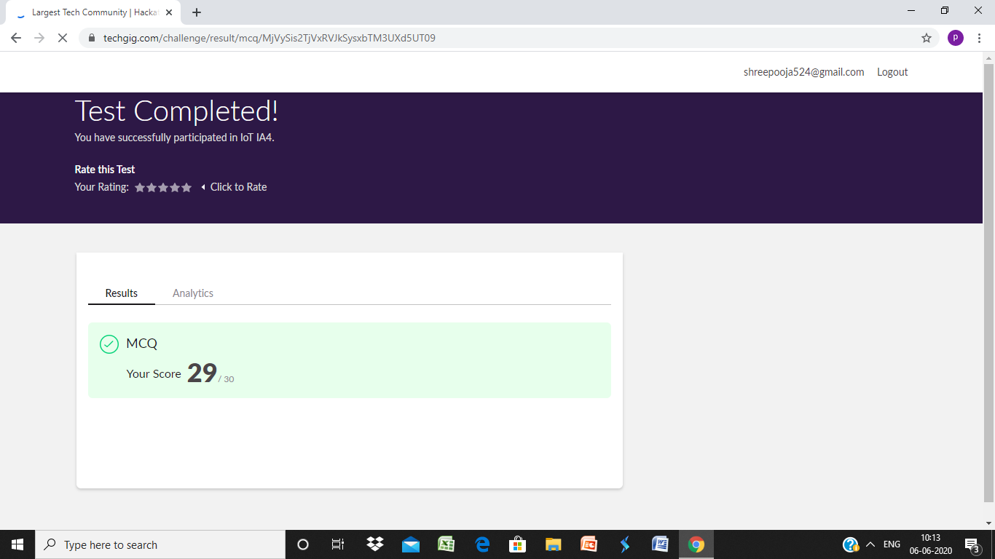

**Certification course**

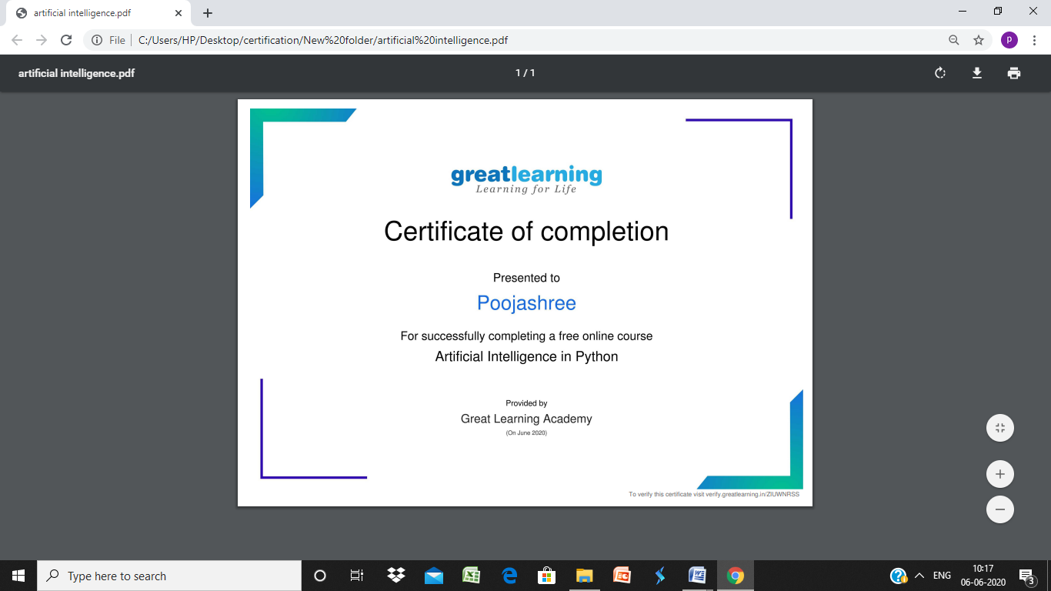

**Coding**

**Program 1**

C programming code to toggle each character in a string.

#include <stdio.h>

#include <string.h>

int main()

{

char str[100];

int i;

printf("\n Please Enter any String: ");

gets(str);

for (i = 0; str[i]!='\0'; i++)

{

if(str[i] >= 'A' && str[i] <= 'Z')   
 {   
 str[i] = str[i] + 32;   
 }   
 else if(str[i] >= 'a' && str[i] <= 'z')

{

str[i] = str[i] - 32;

}

}

printf("\n Toggoled string: %s", str);

return 0;

}